CS 3305-01 Web Programming 2

Instructor: Professor Jim Casale

Name: Anonymos

Written Assignment Unit 2

**Part 1:**

The result of executing the provided code is shown below.

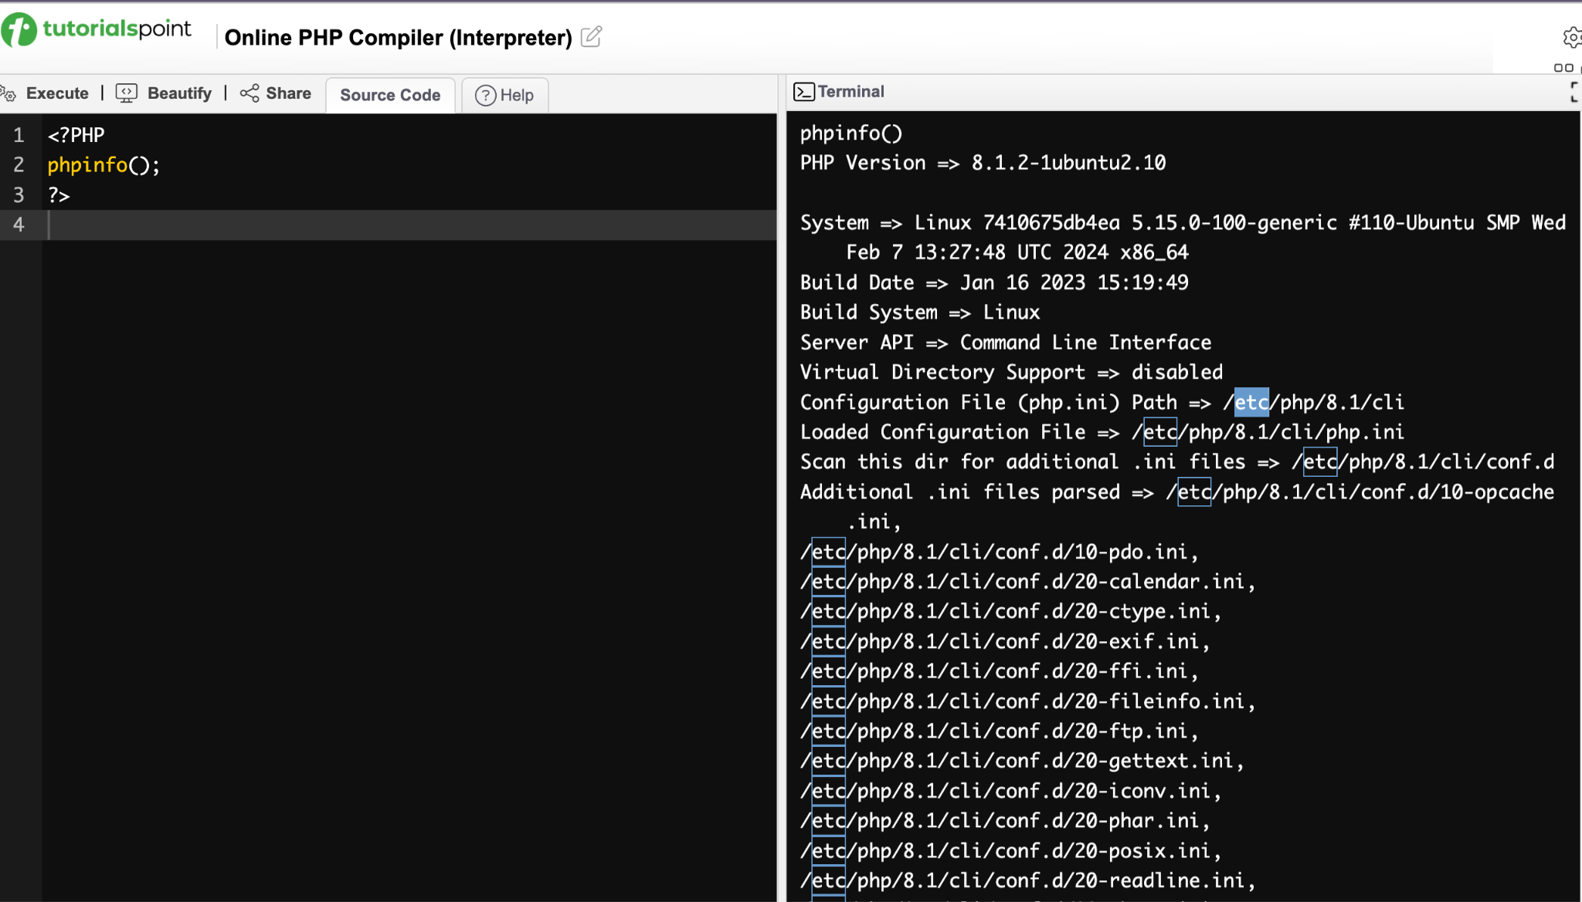

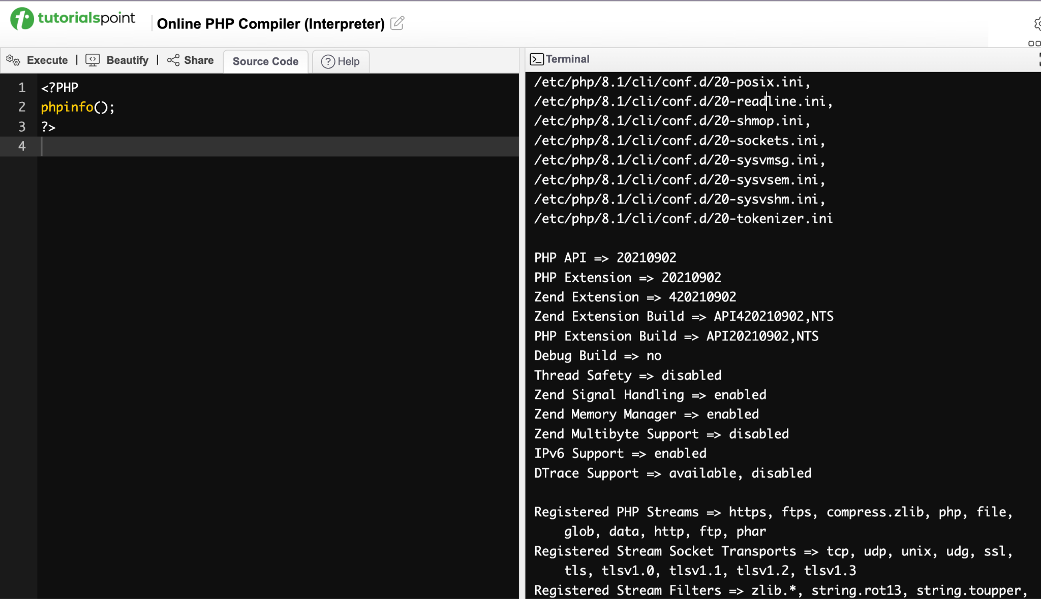

Figure 1. Output of the phpinfo() command displaying the server configuration.

**Part 2:**

I have created the PHP code to obtain the specified output. The requirements for this task can be summarized as follows:

* The first line, "PHP is sorta Fun!" needs to be displayed in bold.
* The second through fourth lines, "My Hello world! program", "There is a lot more to learn about PHP!", and "My name is yourname_" should be displayed on separate lines with appropriate line breaks.

The PHP code that fulfills these requirements, along with a screenshot of its output, is provided below.

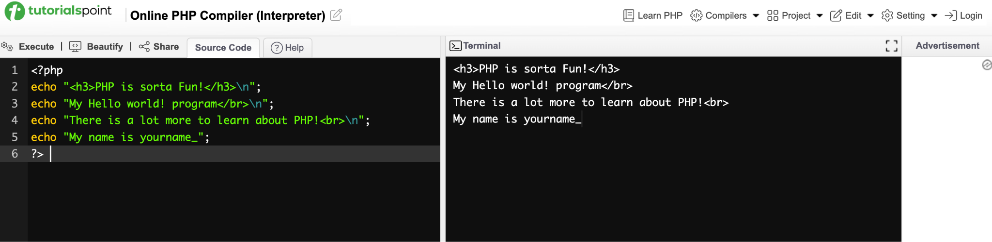

Figure 2. PHP code execution showing the formatted output with bold text and line breaks.

From this result, I confirmed that the PHP code correctly meets the requirements. Additionally, I verified the output of the HTML by testing it on another HTML validation site, and the screenshot of this confirmation is included below.

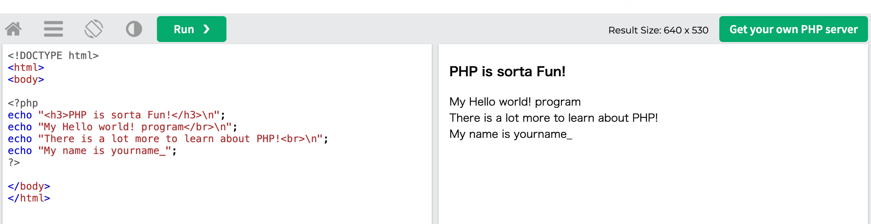

Figure 3. Verification of the PHP output on an external HTML validation site.

Based on these results, I confirmed that all the requirements have been successfully met.

Word Count: 189

References

1. tutorialspoint. (n.d.). *tutorialspoint.com.* Retrieved from https://www.tutorialspoint.com/execute_php_online.php
2. PHP 5 Tutorial. (n.d.). *w3schools.com.* Retrieved from https://www.w3schools.com/php/default.asp